EXPERIMENT-5

Aim: write SQL queries for the aggregate functions (sum,count,min,max,avg)

Creating a table:

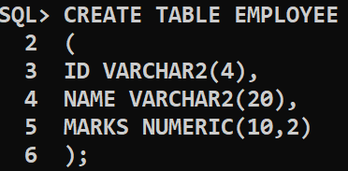

Inserting values into table :

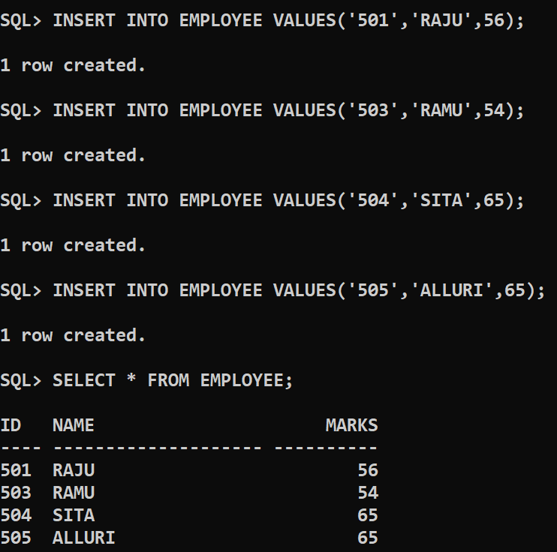

Sum(); 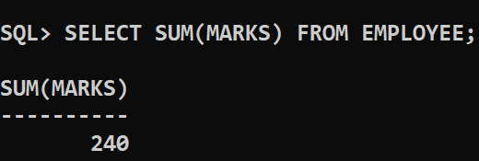

Avg();

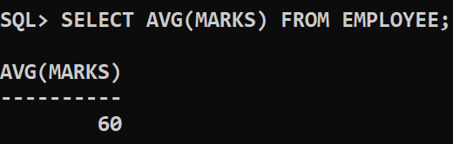

Min();

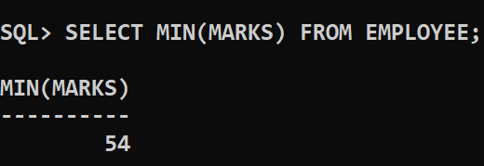

Max();

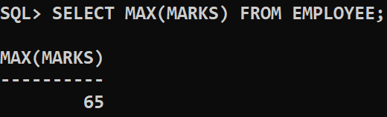

Count();

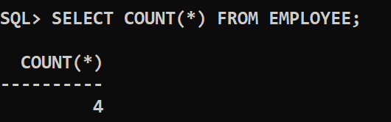

CONCLUSION : SQL queries to perform AGGREGATE FUNCTIONS are successfully executed